Process of Fine-tuning a Phi-4 Models in HuggingFace Space (Jabez)
LoRA Fine-Tuning Method
Hardware:
To install unsloth, you need to have CUDA in your environment.
So, we have a line where we get the image from Docker hub and create a container for it

Environment
Full Requirements: https://github.com/unslothai/unsloth
One of the requirements for installing Unsloth is to have your python version to be > 3.9
For example, our container python version is 3.11
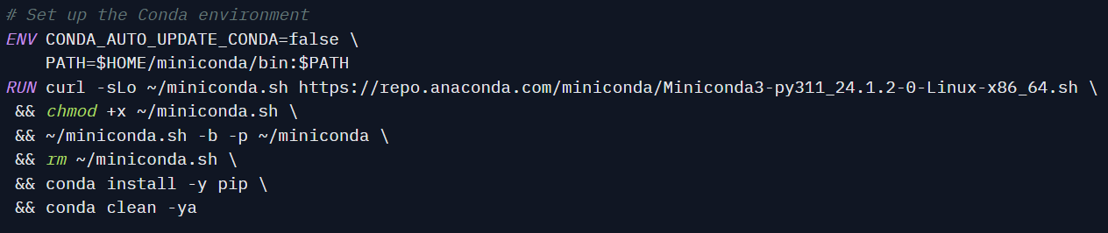
Another requirement is Pytorch
You can the installation command from:
https://pytorch.org/get-started/previous-versions/
WARNING: Due to Unsloth dependencies, Unsloth only worked with some CUDA version and Pytorch version so make sure to read the Unsloth Documentation.
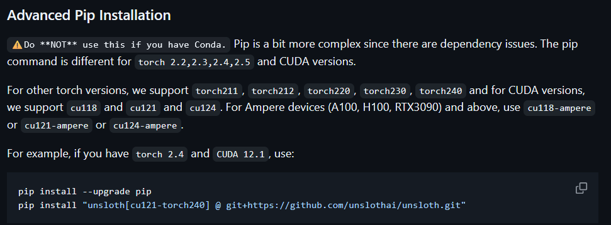

For example, our container has CUDA 12.8 and Pytorch 2.7.0
Import Module
If you can install unsloth, you can see this
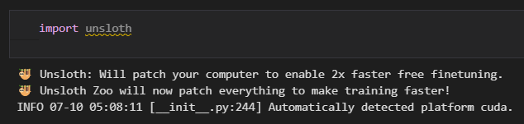
Install requirement.txt
jupyterlab==4.2.5
tornado==6.2
ipywidgets
unsloth>=0.3.0
vllm
torch>=2.0.0
transformers>=4.36.0
datasets>=2.14.0
trl>=0.7.4
accelerate>=0.24.0
bitsandbytes>=0.41.0
scipy>=1.11.0
click>=8.0.0 # Required by wandb/trl
wandb>=0.15.0 # Optional but good to have explicitly listed

Turn off some Optimization
Due to how recent Unsloth library is, there some optimization we need to change to fine-tune the model.
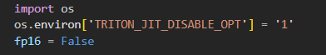
This disables Triton JIT optimizations in PyTorch. It helps avoid numerical instability or compatibility issues during model training or fine-tuning with frameworks like Unsloth.
The “fp16 = false” sets the precision mode to full precision (FP32) instead of half precision (FP16). It useful for avoiding potential underflow/overflow issues during training.
The “modeling_utils” is internal utility module from Hugging Face's Transformers library.
That code ensures ALL_PARALLEL_STYLES is defined, which lists the valid model parallelism strategies and adds support for different weight distribution strategies like:
- "tp": tensor parallelism
- "colwise" and "rowwise": column-wise and row-wise partitioning
- "none": no parallelism
It’s required by Unsloth for compatibility with some versions of the Transformers library that may lack this attribute.

Import Phi-4 model
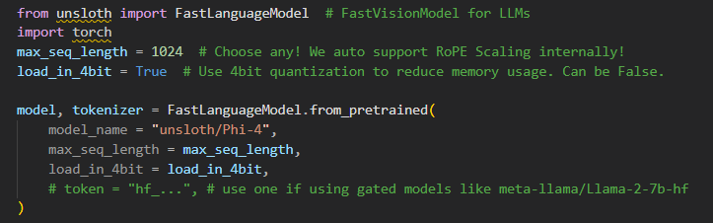

We use the FastLanguageModel from the Unsloth library to import the LLM—in this case, Phi-4. The max_seq_length defines the maximum input sequence length. Due to a known Triton issue, it is recommended not to exceed 1024. The load_in_4bit option enables 4-bit quantized loading to significantly reduce VRAM usage.
Enable Lora adapter
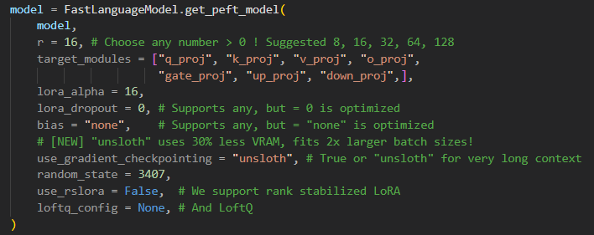
We apply LoRA using “get_peft_model()” from Unsloth to enable parameter-efficient fine-tuning. The r value is set to 16, which defines the rank of the low-rank adapters. LoRA is applied to projection layers listed in “target_modules”. “lora_alpha” scales the LoRA updates, while “lora_dropout” and bias are set to optimized values for better memory usage. “use_gradient_checkpointing” is set to "unsloth" to support longer input sequences with reduced VRAM. Additional options like “use_rslora” and “loftq_config” are disabled in this setup.

Data Preparation
Combine all imported JsonL to one dataset
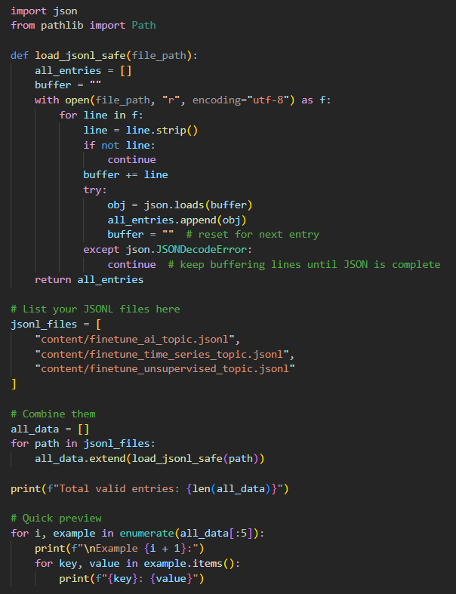
We define a helper function "load_jsonl_safe()" to safely read ".jsonl" files line by line. This approach ensures incomplete JSON entries are skipped and properly parsed. Three fine-tuning datasets are loaded from the "content/" directory, each covering different topics (AI, time series, unsupervised). The entries are aggregated into a single list, and a quick preview prints the first few examples for validation. This preprocessing step is essential to prepare the training data for instruction tuning.
Import the tokenizer for Phi-4
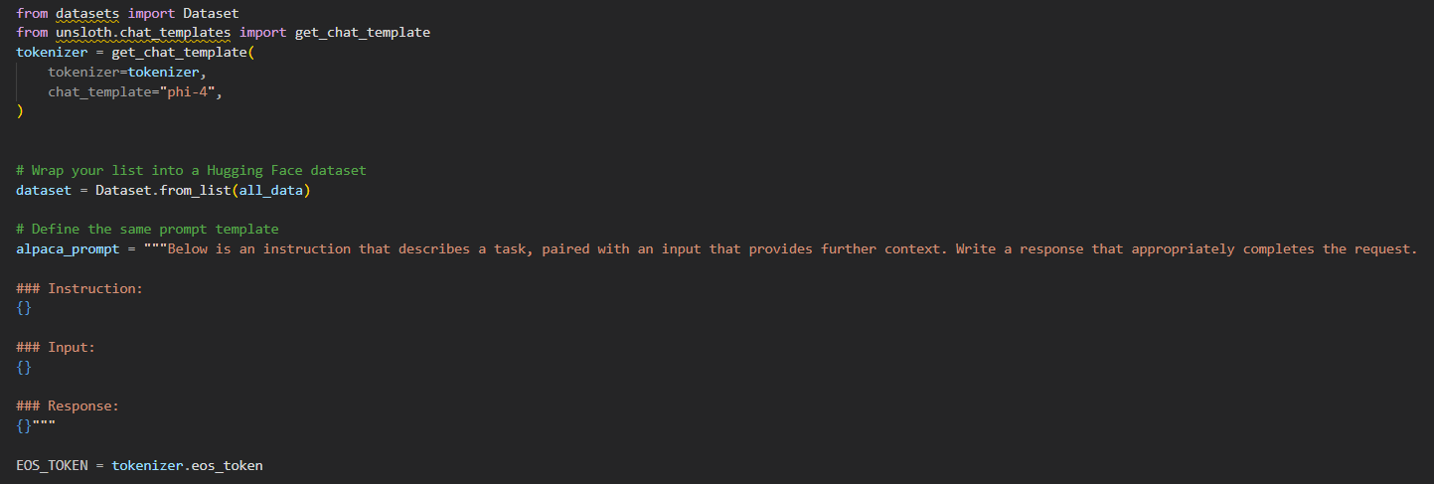
We define the tokenizer using "get_chat_template()" from the "Unsloth" library, specifying "phi-4" as the chat template to match the model's format. This ensures that the tokenizer will format prompts correctly during training. The loaded training data ("all_data") is then wrapped into a Hugging Face Dataset object. Additionally, a consistent prompt format ("alpaca_prompt") is declared to structure each training example with "Instruction", "Input", and "Response" fields. This setup ensures alignment between the model, tokenizer, and fine-tuning data.
Format the dataset with the tokenizer
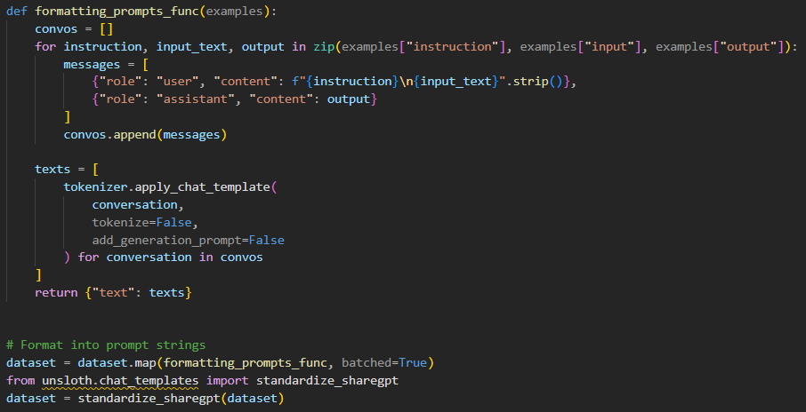
We format the dataset into a prompt-response structure using "formatting_prompts_func()". Each example is converted into a conversation-style message, where the user's input includes both the instruction and context, and the assistant provides the expected output. The tokenizer's "apply_chat_template()" function wraps each example in the correct format expected by the Phi-4 model. After mapping the formatting function across the dataset, we apply "standardize_sharegpt() "from Unsloth to ensure compatibility with ShareGPT-style conversational formatting.

Start the FineTune
Define the training parameters
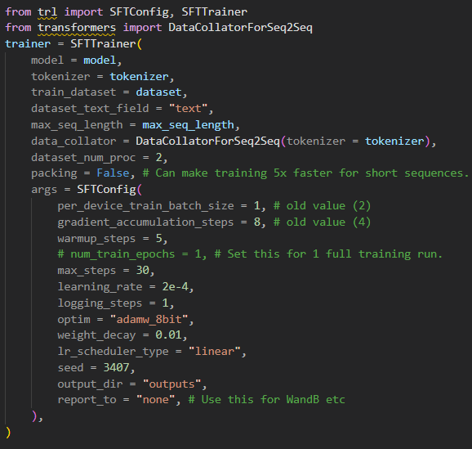
We define the training configuration using SFTTrainer and SFTConfig from the trl library. The fine-tuning dataset is passed along with the tokenizer and model. Training parameters are specified within SFTConfig, including:
- per_device_train_batch_size = 1: mini-batch size per GPU
- gradient_accumulation_steps = 8: simulates a larger batch size
- learning_rate = 2e-4 and weight_decay = 0.01: optimizer hyperparameters
- max_steps = 30: total number of training steps (instead of epochs)
- warmup_steps = 5: warmup for learning rate scheduling
- optim = "adamw_8bit": uses 8-bit optimizer for memory efficiency
- output_dir = "outputs": where model checkpoints will be saved
- report_to = "none": disables logging to external tools like Weights & Biases
The setup also includes DataCollatorForSeq2Seq and sets packing=False, meaning sequences are padded instead of concatenated.

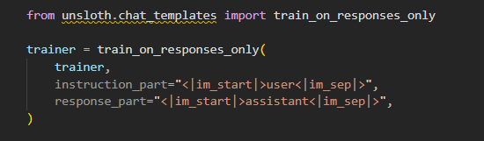
We apply train_on_responses_only() from Unsloth to configure the trainer to focus solely on learning the assistant's reply. This is done by specifying the special token markers:
- instruction_part: identifies the user message section.
- response_part: identifies the assistant’s response section.
This approach ensures that the model is trained only on generating appropriate outputs, while ignoring the loss for the instruction and input parts.
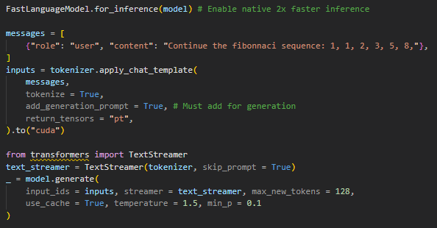
After training, we perform inference using FastLanguageModel.for_inference() to enable optimized decoding. A test message is structured as a chat input (in this case, asking to continue the Fibonacci sequence). The input is formatted using the tokenizer with generation-specific settings. TextStreamer from Hugging Face is used to stream the output tokens live. The generation is performed with parameters like temperature = 1.5 and min_p = 0.1 to encourage creative sampling. This confirms that the model is functioning and can generate completions based on user prompts.

Example completion:
The Fibonacci sequence is a series of numbers where each number is the sum of the two preceding ones, usually starting with 0 and 1. In this case, the sequence starts with 1 and 1.

The next number in the sequence is found by adding the last two numbers. So, to find the next number after 8, we add 5 and 8 to get 13.

Continuing this pattern, the next number is found by adding 8 and 13 to get 21.

The next number is found by adding 13 and 21 to get 34.

Save the Model
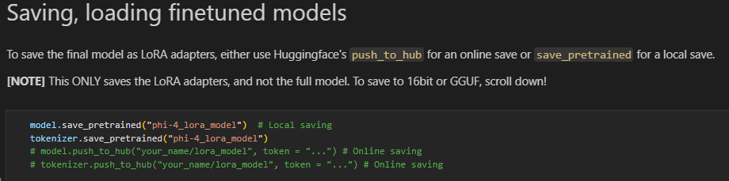
To use back the adapter again
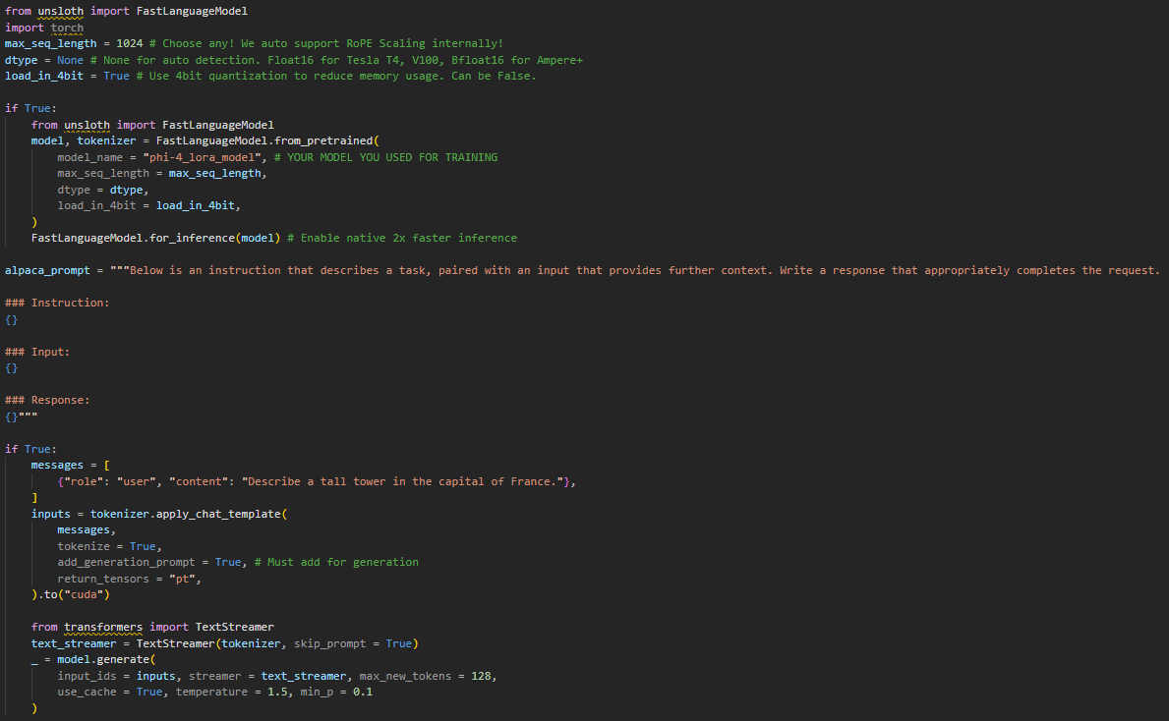

Prompt-Tuning Method
The Hardware and Environment are both same as the LoRA’s hardware and environment.
Prerequisites
Before importing the Phi-4 model, we configure the environment variable HF_HUB_DISABLE_XET to ensure compatibility with the container environment.
By default, some Hugging Face models, including Phi-4, rely on XetHub for large file synchronization. However, this dependency is not available in certain Docker or Jupyter environments. Setting this variable disables XetHub access and allows the model to be downloaded through the standard HTTP method instead.
This step is important to prevent errors during model loading, especially in environments that do not have the XetHub client installed
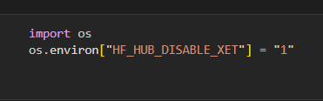
Importing Phi-4 Model
After setting up the environment variable, we proceed to import the Phi-4 model and its corresponding tokenizer from Hugging Face’s Transformers library.
The AutoTokenizer handles text preprocessing, while AutoModelForCausalLM loads the pretrained Phi-4 architecture for causal language modelling tasks.
The model_name variable specifies the exact model to be used. In this example, we use microsoft/phi-4, but any compatible Phi-series model can be substituted.
To ensure compatibility across hardware, we set torch_dtype="auto", which automatically selects the appropriate data type based on system capabilities (e.g., FP16, BF16, or FP32).
The device_map=None option forces the model to load on CPU first, which is recommended for environments with limited VRAM.
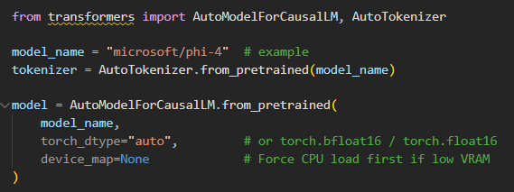
Soft Prompt Adapter
To perform fine-tuning using Soft Prompt Tuning, we configure a set of virtual tokens that serve as learnable continuous embeddings prepended to the model’s input.
Unlike LoRA, which injects low-rank adapters into the model’s weight matrices, Soft Prompt Tuning only trains these virtual tokens while keeping all other model parameters frozen.
Defining PromptTuningConfig from the PEFT library
task_type=TaskType.CAUSAL_LM | sets the model’s training mode for causal language modelling tasks
prompt_tuning_init=PromptTuningInit.TEXT | initializes the virtual prompt using a short text phrase
prompt_tuning_init_text="Answer the following:" | defines the textual template for initialization
num_virtual_tokens=20 | specifies the number of virtual tokens to be trained (typically 8–20)
tokenizer_name_or_path="microsoft/phi-4" | ensures that the tokenizer aligns with the Phi-4 model
Then we wrap the model using get_peft_model() to apply the soft prompt adapter.
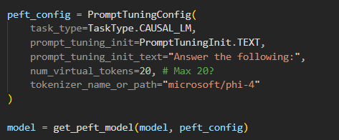
We then verify the number of trainable parameters to ensure that only the prompt embeddings are updated during fine-tuning.
This confirms that the base model remains frozen, minimizing memory usage and training time.
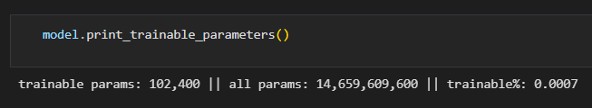

Data Preparation
In this section, we prepare the dataset used for soft prompt tuning. The data follows the Alpaca-style instruction–response format, containing fields such as instruction, input, and output.
We load the dataset using the Hugging Face Datasets library.
Next, we construct a simple text field by merging the instruction, input, and output into a single formatted text string.
This helps the tokenizer process the data efficiently and ensures consistency with the prompt-based training setup.
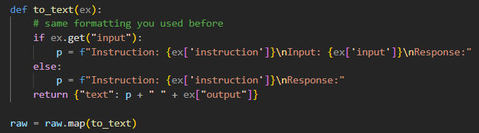
This function ensures that:
- Every dataset entry contains a unified text field named "text".
- The formatting follows a consistent conversational template
(Instruction → Input → Response).
Tokenize the dataset
Once the text data has been pre-processed, we proceed to tokenize the dataset.
Tokenization converts each formatted text entry into input tensors (input_ids and attention_mask) that the model can process.
We define a custom tokenization function that truncates inputs to a maximum sequence length of 1024 tokens and includes special tokens required by the model.

To optimize memory and prevent unused fields from being passed to the trainer, we retain only the essential tensors used by the model: input_ids and attention_mask.
This ensures that the dataset is in the correct format for efficient training, with only the necessary fields included for tokenized inputs.
At this point, the tokenized dataset (train_ds) is ready to be passed into the SFTTrainer for fine-tuning with the soft prompt configuration.
Train the Model
After tokenization, we configure the data collator, define a safe training loop, and specify the hyperparameters for soft prompt tuning.
Data Collator
We use DataCollatorForLanguageModeling from the Transformers library.
This collator takes care of dynamic padding within a batch and automatically creates the labels tensor from the input IDs.
Since Phi-4 is trained as a causal language model, we disable masked language modeling by setting mlm=False.
SafeSFTTrainer
To make the training loop more robust, we subclass SFTTrainer and override the compute_loss method.
The goal is to handle potential length mismatches between the model outputs and the labels, and to compute a standard autoregressive cross-entropy loss.
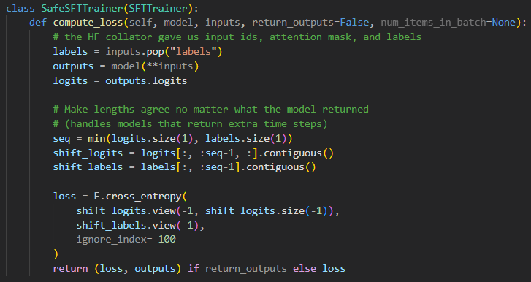
We then define the training hyperparameters using SFTConfig.
These settings control batch size, learning rate, number of steps, optimizer type, and logging behavior.
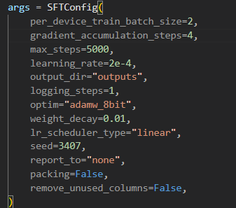
Safety Settings
Some Transformer models can raise errors during training if certain configuration flags remain enabled.
In particular, use_cache=True can interfere with gradient computation, and logits_to_keep (if present) can truncate the logits needed for the loss.
To avoid these issues, we explicitly update the model configuration before creating the trainer:
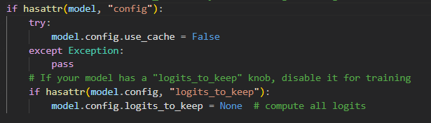
• use_cache=False ensures that the model does not reuse past key/value states during training, which can otherwise break backpropagation in some setups.
• Setting logits_to_keep=None guarantees that the full logits tensor is returned so the loss can be computed correctly for every time step.

Start Training
After adjusting the configuration, we instantiate the SafeSFTTrainer with the model, tokenizer, dataset, data collator, and training arguments:
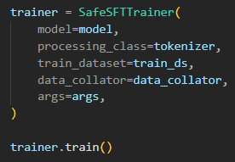
Once trainer.train() is called, the training loop begins and only the soft prompt virtual tokens are updated, while the Phi-4 base model stays frozen.
Save the Model
After training is complete, we save the prompt-tuned Phi-4 model together with its tokenizer so that the soft prompt configuration can be reused later without rerunning training.
Using the standard Hugging Face save_pretrained() method, we store everything in a dedicated directory named phi4_prompt_tuned:
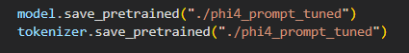
Inference
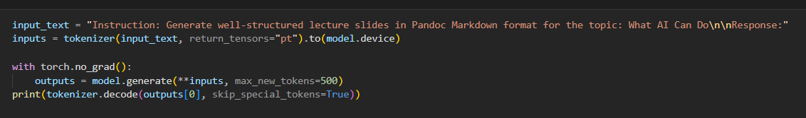

APPENDIX
FILE:
Dataset example:
LoRA File:
Dockerfile for environment:
Prompt-tuning File:

